Aim:

To perform ARP attack on website

ARP ATTACK:

Address Resolution Protocol (ARP) is a stateless protocol used for resolving IP addresses to machine MAC addresses. All network devices that need to communicate on the network broadcast ARP queries in the system to find out other machines’ MAC addresses. ARP Poisoning is also known as ARP Spoofing.

Procedure:

STEP -1

OPEN TERMINAL AND GO TO ROOT USER AND GET KALI IP -IFCONFIG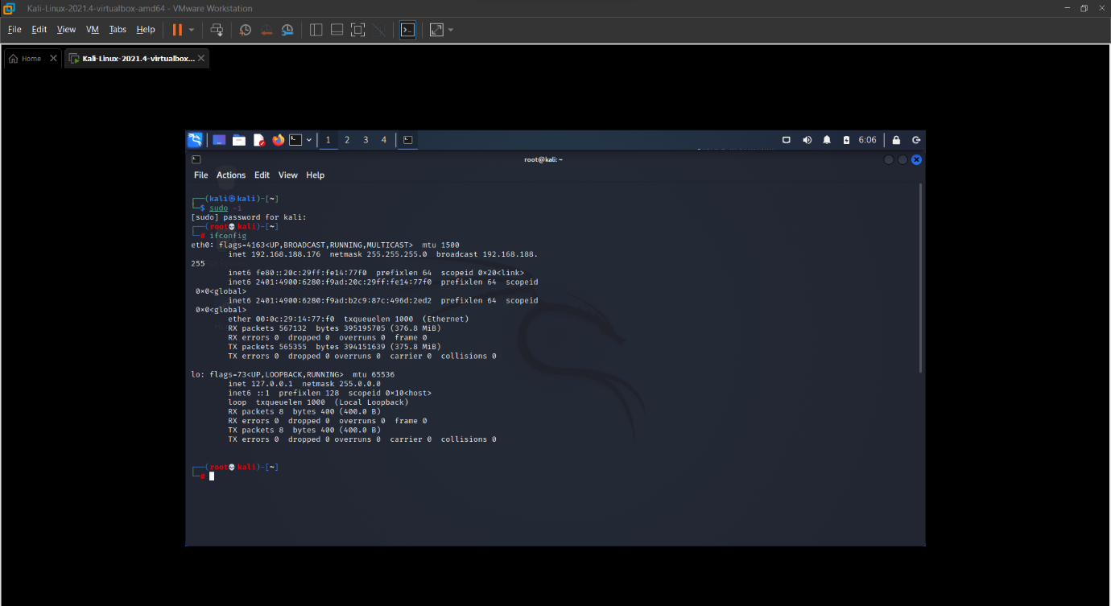

STEP -2

Go to cmd and get host IP using – IPCONFIG

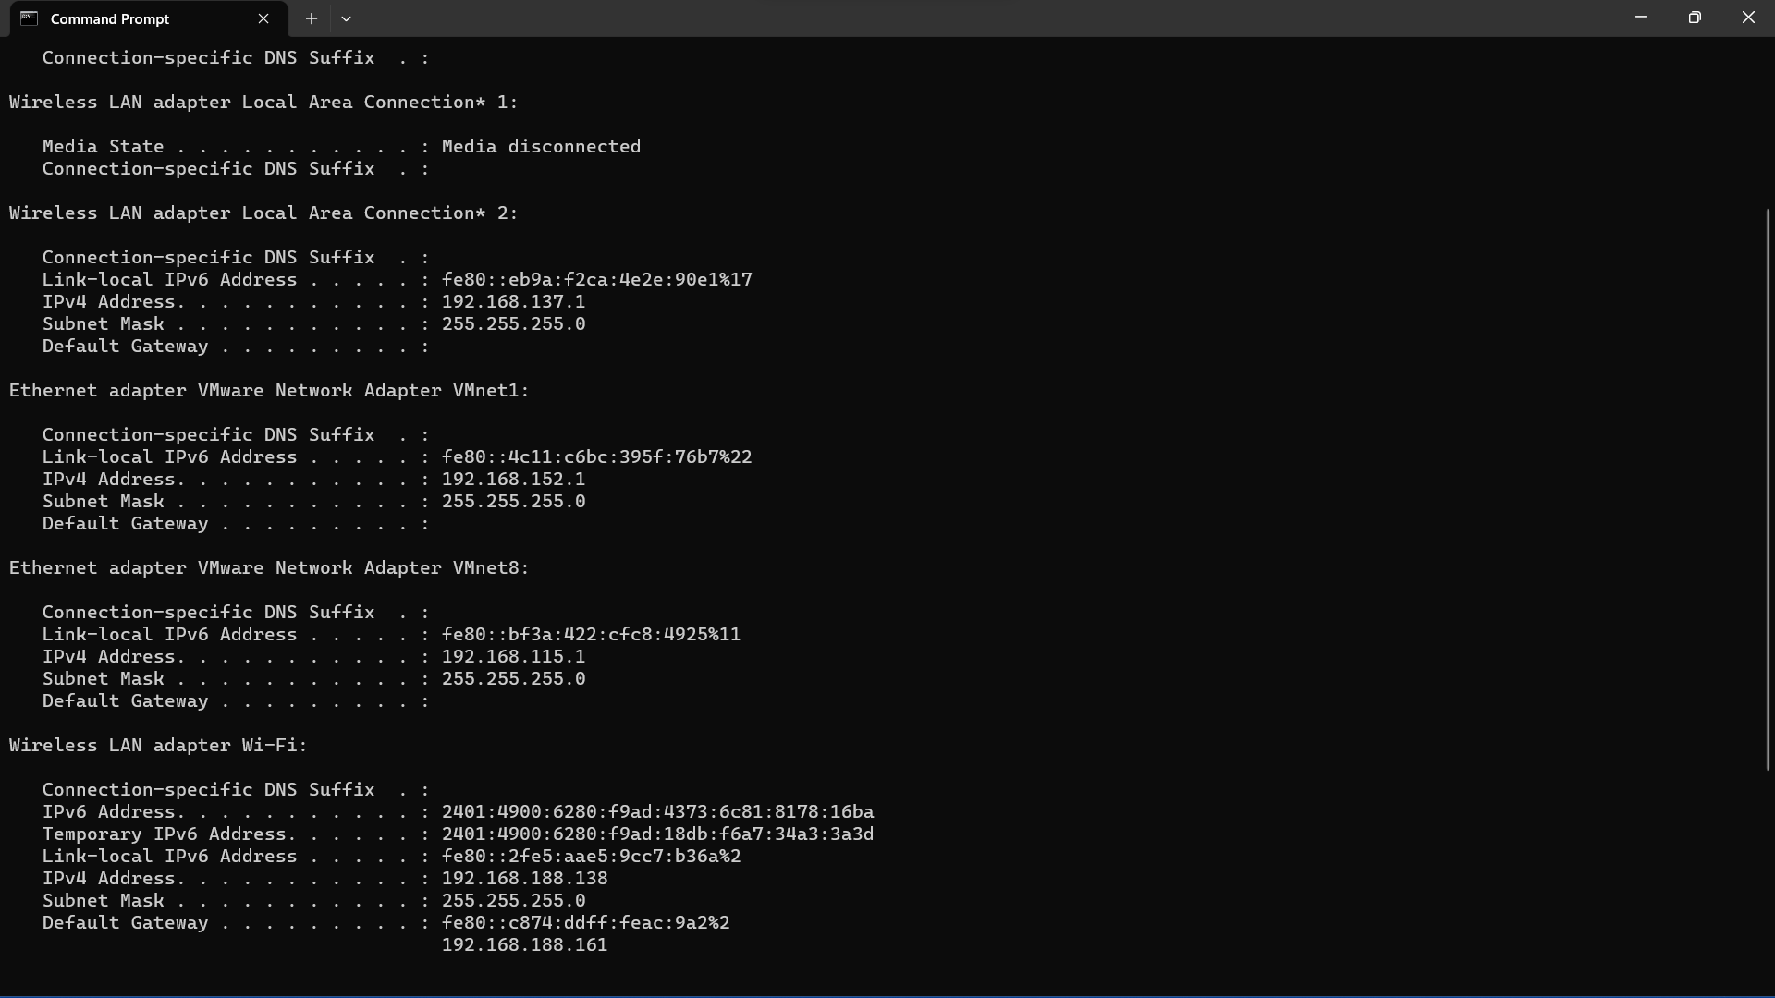

STEP -3

OPEN ETTER CAP

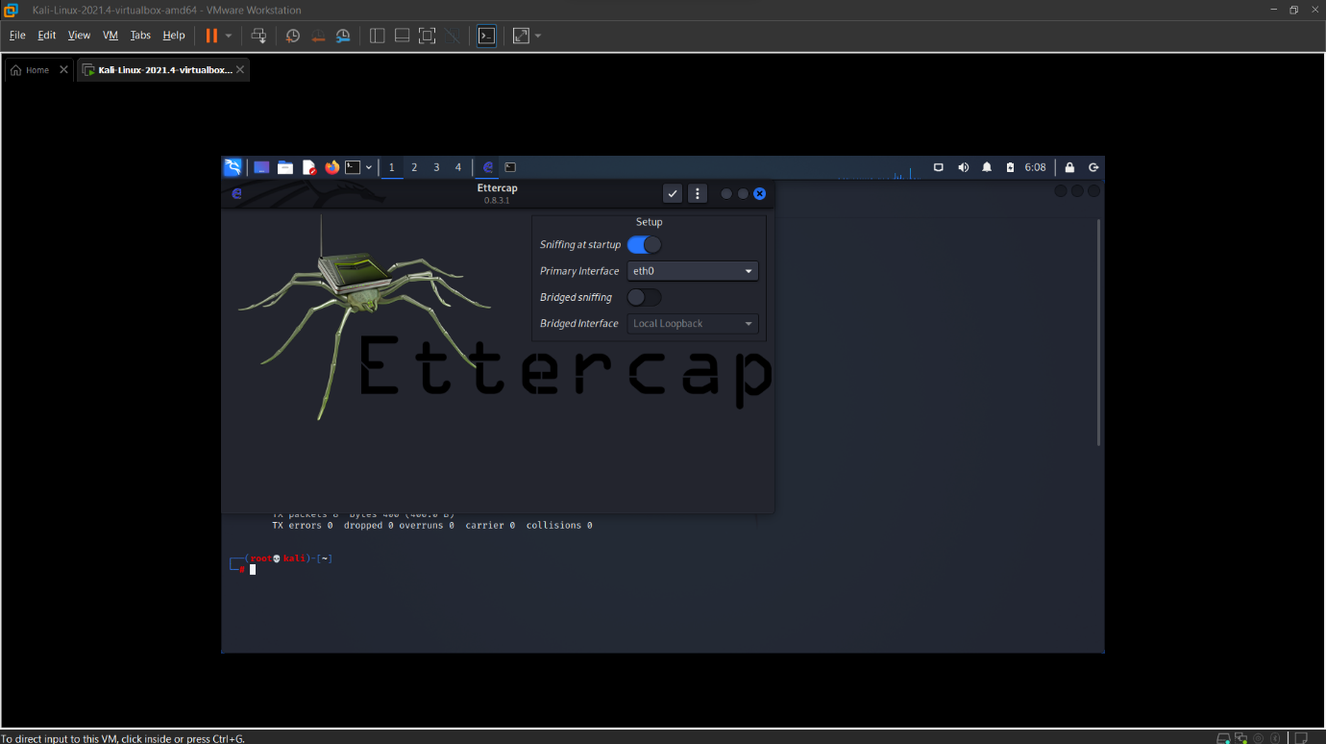

STEP -4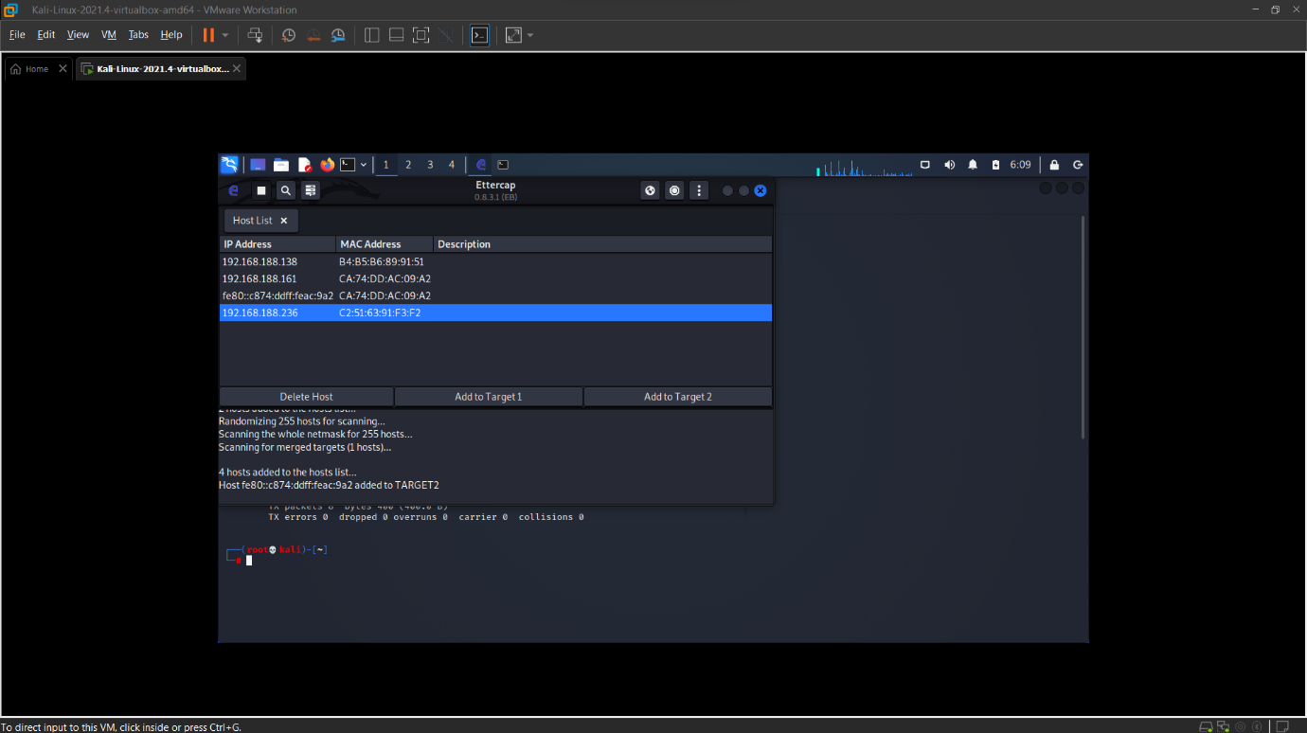

STEP -5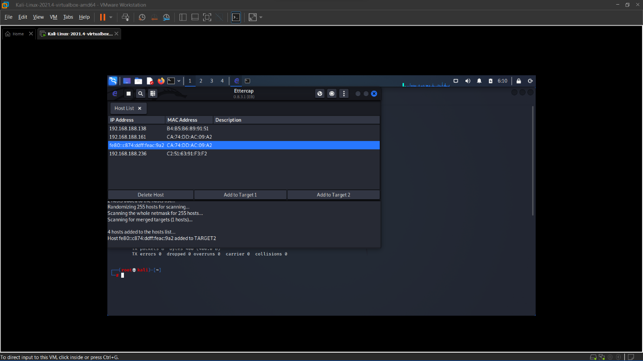

STEP -6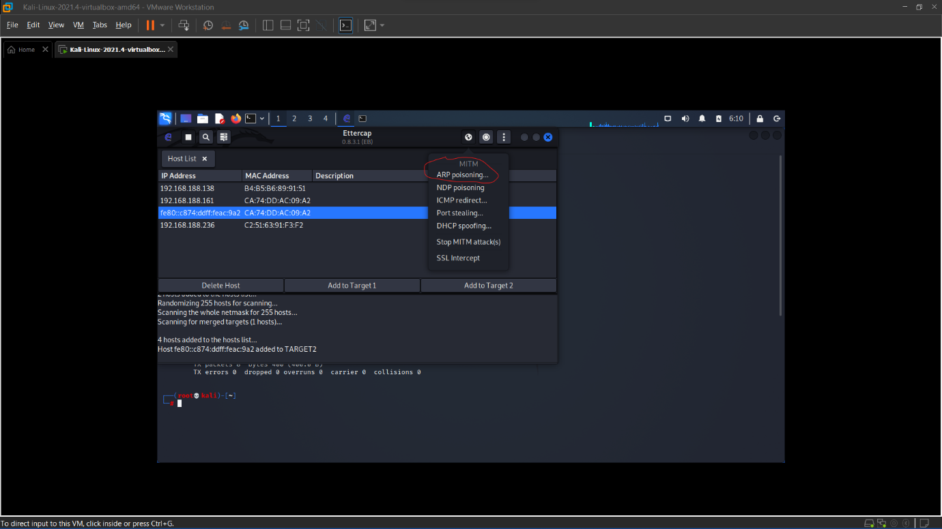

STEP -7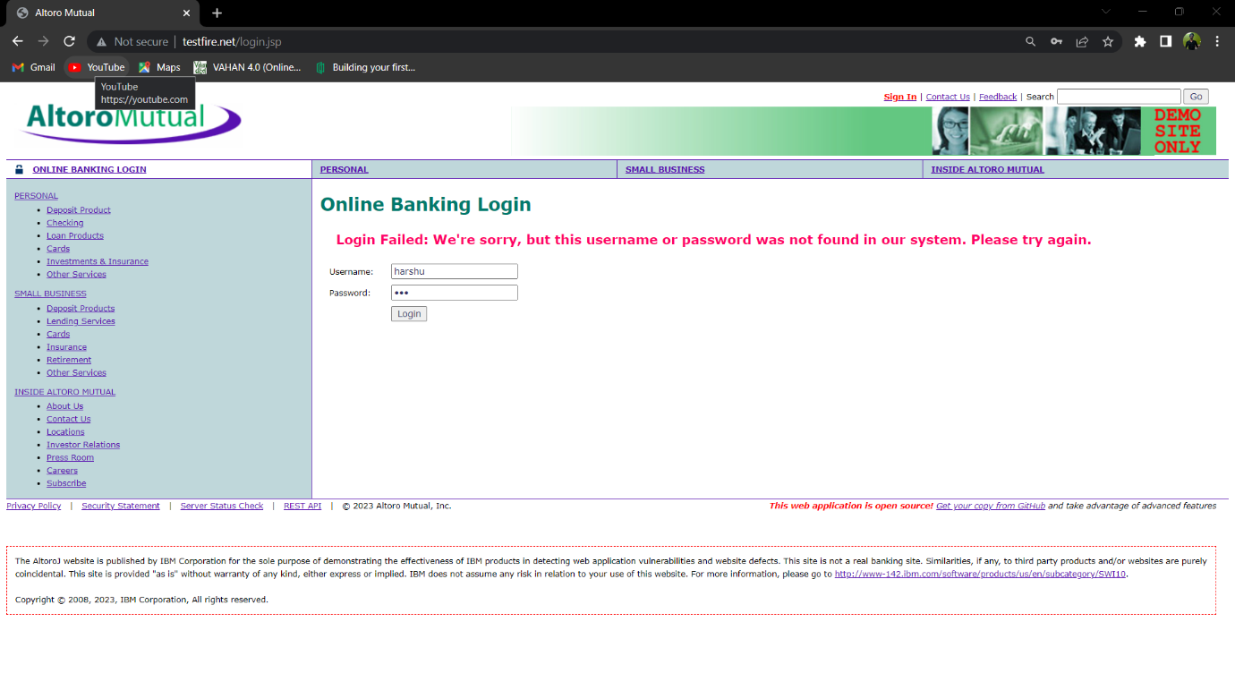

STEP -8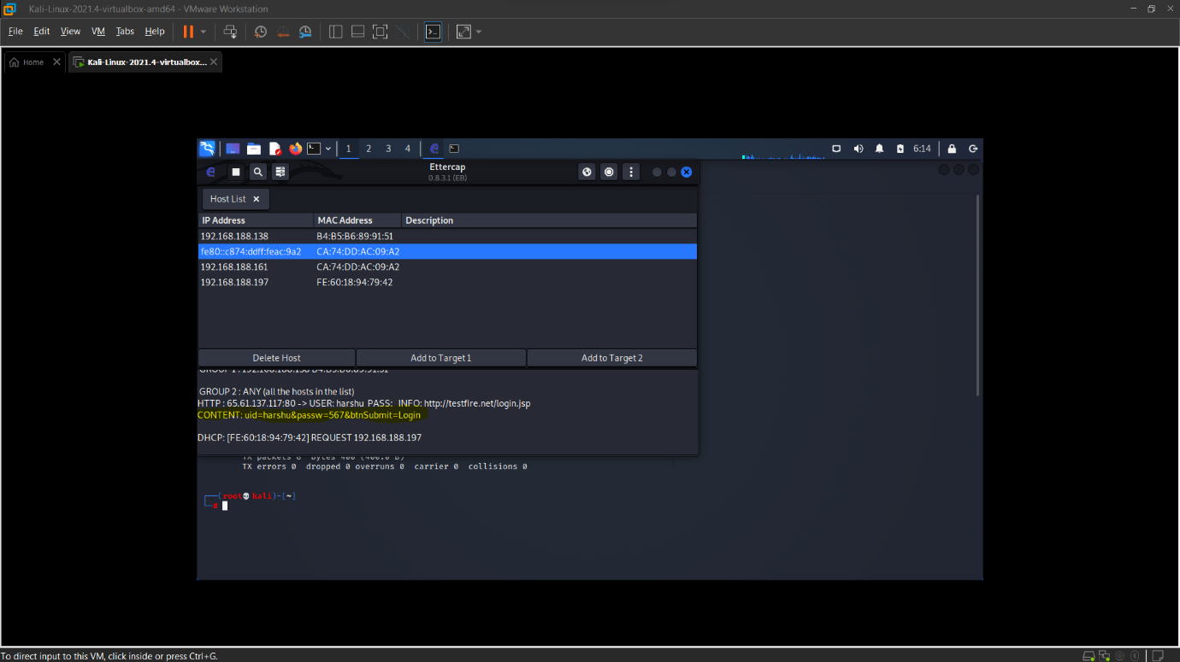

Result:

……Write your own result……